**

Mohammad Ali Jinnah University

Chartered by Government of Sindh - Recognized by HEC

Portfolio Maker

**Subject**: Database Management System (DBMS)

**Section**: BM

**Teacher**: Rimsha Javed

**Muhamad Fahad** (FA19-BSSE-0014)

(FA19BSSE0014@maju.edu.pk)

**Ahmed Amin** (FA19-BSSE-0063)

**(**FA19BSSE0063@maju.edu.pk**)**

# Module 1

* **Analysis of Business Problem**
* **Identification of entities, relationships, users and their roles**
  + - **Entities**:
      * User
      * Experience
      * Skills
      * License
      * Owner
      * Information
      * Contact
      * Personal info
      * Project details
    - **Relationships**:
      * A User can change its information, Info of that user can only change by him.

**(One to One Relationship).**

* + - * A user may have different social media link, Different link belongs to a user **(One to many Relationship).**
      * A user may have different Project, Different Project belongs to a user

**(One to many Relationship).**

* + - * A user may have different Experience, Different Experience belongs to a user **(One to many Relationship).**
      * A user may have different Experience, Different Experience belongs to a user **(One to many Relationship).**
      * A user has a License key, Single License key belongs to a user

**(One to One Relationship).**

* + - **Users roles**:
      * **Guest**:
        + Can only view different Portfolio.
        + Contact with the Specific User.
        + Contact with the Admin.
      * **User**:
        + V
      * **Admin**:
        + d
* 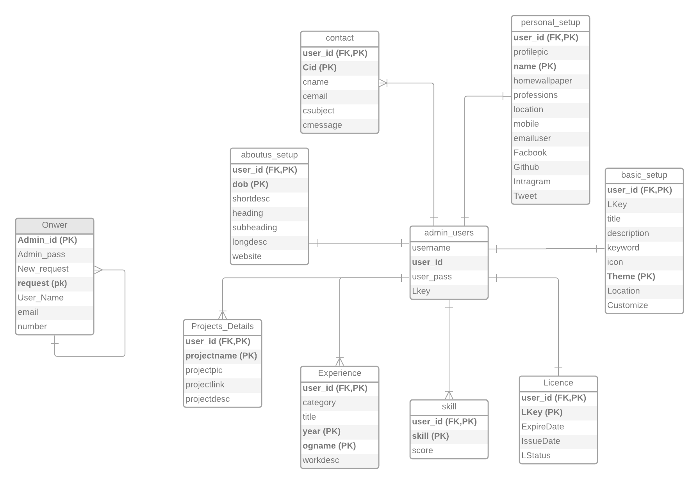**Entity Relationship Modeling (ER Diagram):**

The ER diagram need some Normalization on different table (**Owner, Personal setup, basic setup**).

* **Normalization**
* **Finalize Entity Relationship Modeling (ER Diagram):**

